VISHWACON 2019
on
"Recent Trends in Engineering & Technology"
3rd National Conference was organized by Vishwakarma Institute of Information Technology (VIIT), Pune in association with Savitribai PhulePune University (SPPU) on 8th& 9th February 2019. Mrs. R.G.Purandare (E&TC Dept.) was the Convener and Mrs. S.R.Rathi(Comp Dept) was the Co-Conveners for the conference.Papers were invited on current topics in streams of Information Technology, Electronics& Telecommunication, Mechanical, Computer, andCivil engineering. The organizing team received a very good response and 175papers were selected for oral and poster presentation. Best papers in all categories were awarded prizes.DrM.V.Pitkefrom the Tata Institute of Fundamental Research (TIFR), Mumbaiand one of the founderdirectors of the Centre for Development of Telematics (CDOT)had kindly consented to be the chief guest for the inaugural ceremony. Mr. Amit SDeshpande Director-Operations at Konecranes, Pune was the key note speaker.He spoke on “Recent Trends in Engineering & Technology” and also addressed the issue of preparation for a successful career in industry. CD of the conference proceedings was released on this occasionswithISBN No : 978-93-88424-23-3Accepted papers will be available online on Institute research journal - "Vishwakarma Journal of Engineering Technology" ISSN:2456-8465. Industry professionals also attended the event in big number.‘Best Industry Partner’ awards were given away on this occasion to the industry which has actively participated in important institute and student activities by giving internships, projects and placements to students, industry training to faculty members in the year 2018-19. Overall it was a successful event for the institute.

INAUGURATION CEREMONY
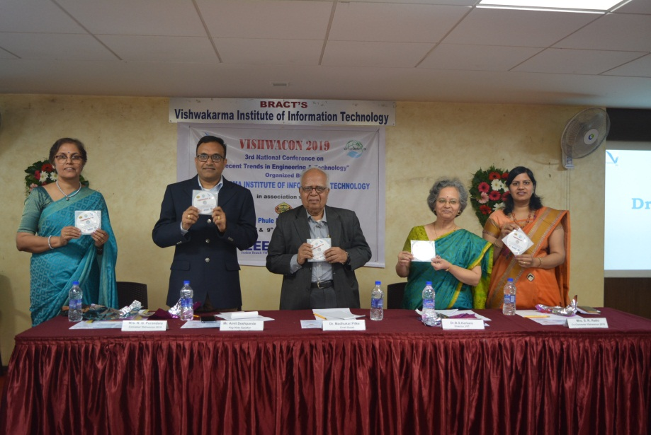

KEY NOTE SPEAKERS
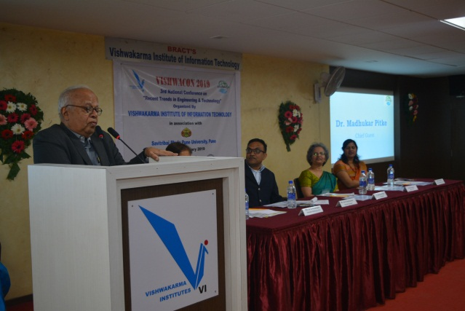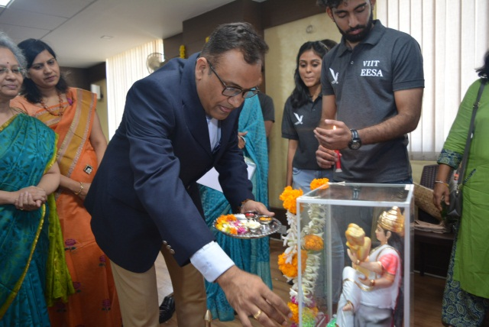

PAPER PRESENTATIONS
